Academic and Career Guidance Content
Envisioning Future Possibilities


Community
Career
Personal

LIFE PROJECT: Anticipate the process involved in producing a draft of one or more future projects (personal, career or community)

Student Booklet

Name: ____________________________
Introduction
Throughout your life as a student, you have completed numerous class projects.
In this learning situation you will work on your LIFE PROJECT where you will anticipate the process involved in producing a draft of one or more future projects (personal, career or community).
This learning situation will allow you to:
- express ideas and imagine different scenarios about what you would like to do,
- select the most plausible scenario in order to choose a direction in life once you have completed secondary school,
- convert your thoughts into a draft of a personal, career or community project,
- encourage you to think about the decisions you will have to make in life once you have completed Secondary Cycle Two.


Anticipate

Part One
Step One:
1. Brainstorm what the term ‘’Project’’ means to you. __________________________________________________________________________________________________________________________________________________________________________________________________________________________________________
2. In the chats below, answer some of the following questions:
- What were some of your project topics?
- What did you do to begin a project?
- What did you need to begin a project?
- What steps did you take in order to complete the project?
- How long did it take you to complete it?
- How did you plan for your project?
- What resources did you use to complete the project? (people, materials, etc.)

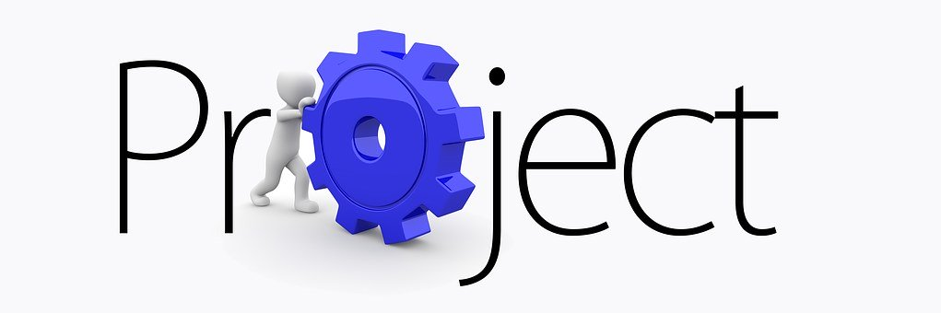

3. Brainstorm what the term “Life Project” means to you.
__________________________________________________________________________________________________________________________________________________________________________________________________________________________________________

Step Two:
For your project to be personal and meaningful, it needs to reflect who you are.
List some of your interests, aptitudes, aspirations and values in the table below. You may refer to your Personal Profile as needed.

Interests  | Aptitudes  | Aspirations | Values  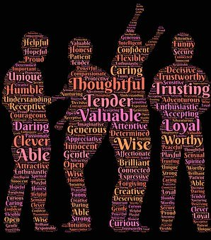

Step three: definitions for terms
There exist several types of Life Projects. For this learning situation you will learn about three types of projects.

In groups, discuss and provide your own definition of each type of Life Project:

Personal:

Career:

Community:

Step four: Providing examples of life projects for one category
- From the previous class discussions, provide several examples of Life Projects for one category of your choice:

Possibility #1 |  |  | Personal | ☐ | Career | ☐ | Community | ☐

Possibility #2 |  |  | Personal | ☐ | Career | ☐ | Community | ☐

Possibility #3 |  |  | Personal | ☐ | Career | ☐ | Community | ☐

- Select a Life Project that you would like to carry out. You may indicate your choice by highlighting an item above.

Part two
Steps involved in a Life Project
From the example the teacher provided of anticipating the process involved in obtaining a driver’s licence, you are now ready to use the template on the following pages to anticipate in the context of the Life Project that you would like to carry out.

ELEMENTS TO CONSIDER WHEN DETERMINING THE STEPS IN A PROJECT PLAN (DEPENDING ON THE TYPE OF PROJECT)
Other Resources:
Official websites
Public organizations
Specialized and recognized companies or businesses
Other:
____________________________________________________________________________________________________________________
Personal Network:
My parents (information and discussion)
Guidance counsellors, academic advisors, other school staff
Teachers
Other people who are directly involved in the project (employer, internship supervisor, admissions officers, immigration resource, etc.)
Other:_______________________________________________________________________________________________________________________________

Living Arrangements:
With my family?
Other country?
Which country? __________________
Its culture? Its language?
____________________________________________________________________________________________
In an apartment?
Room and board?
Roommate?
Other:
____________________________________________________________________________________________

Official Documents Required (Select all the relevant documents):
Report Card, Achievement Record/Relevé des Apprentissages (MEQ)
Birth Certificate
Passport
Visa
Reference Letters
Lease
Other :
______________________________________________________________________________________________________
Deadlines (indicate all relevant dates):
To submit a request
To process and analyze requests
To obtain official documents
Other:
_________________________________________________________________________________________________________
Budget:
Directly related to the project (ex. cost of books, tuition):________________________________
Rent:_______________________________
Transport:_______________________________
Food:__________
Clothing:_____________
Resources relevant for the project:________________
Other:
______________________________________________
Financial Needs (e.g. loans and bursaries)?
Resources___________________________________________________________________________________

NOW IT'S UP TO YOU TO consider which section and which steps you will complete

Explain your choice on the basis of what you know about yourself (interests, aptitudes, aspirations, and values...) You may refer to your personal profile.
__________________________________________________________________________________________________________________________________________________________________________________________________________________________________________________________________________________________________
Title:
____________________________________________________________
Type of Life Project:
- Career
- Personal
- Community
Duration:
_______________________________
Draft Plan of My Life Project

In your opinion, what are the different steps you need to plan to carry out your project?
____________________________________________________________________________________________________________________________________________________________________________________________________________________________________________________________________________________________________________________________________________________________________________________________________________________________________________________________________________________________________________________________________________

Place your steps in order. Which one will you do first, and which ones will you do next?
1._________________________________________________________________________________________________________________________________
2._________________________________________________________________________________________________________________________________
3._________________________________________________________________________________________________________________________________
4._________________________________________________________________________________________________________________________________
5._________________________________________________________________________________________________________________________________

Part Three: Integration Phase
- What do you know now that you did not know before?
________________________________________________________________________________________________________________________________________________________________________________________________________________________

- How do you feel about beginning a draft of your Life Project?
________________________________________________________________________________________________________________________________________________________________________________________________________________________

- What resources are available to you?
________________________________________________________________________________________________________________________________________________________________________________________________________________________

- How will what you have recently learned help you plan your schooling? For your future?
________________________________________________________________________________________________________________________________________________________________________________________________________________________

- You began producing a draft of your Life Project. What does your Plan B look like if Plan A does not come to fruition?
________________________________________________________________________________________________________________________________________________________________________________________________________________________

- How could you use the learning strategy “anticipate” in other situations/contexts?
________________________________________________________________________________________________________________________________________________________________________________________________________________________



